Range Hood
Instruction Manual

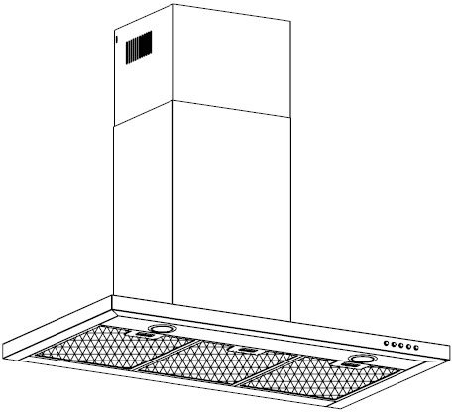

Content
1…………………………………………………………………Safety instructions

2…………………………………………………………………Installation

3…………………………………………………………………Start using your range hood

4…………………………………………………………………Troubleshooting

5…………………………………………………………………Maintenance and cleaning

6…………………………………………………………………Environment protection

SAFETY INSTRUCTIONS
This manual explains the proper installation and use of your range hood, please read itcarefully before using even if you are familiar with the product. The manual should be keptin a safe place for future reference.

Never to do:
● Do not try to use the range hood without the grease filters or if the filters are excessively greasy!
●Do not install above a cooker with a high level grill.
●Do not leave frying pans unattended during use because overheated fats or oils might catch fire.
●Never leave naked flames under the range hood.
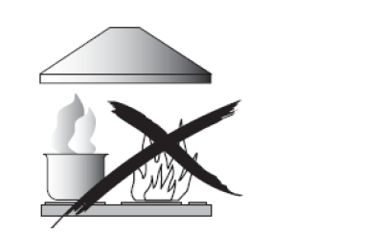
●If the range hood is damaged, do not attempt to use.
●Do not flambé under the range hood.
●CAUTION: Accessible parts may become hot when used with cooking appliances.
●The minimum distance between the supporting surface for the cooking vessels on the hob and the lowest part of the range hood. (When the range hood is located above a gas appliance, this distance shall be at least 75 cm)
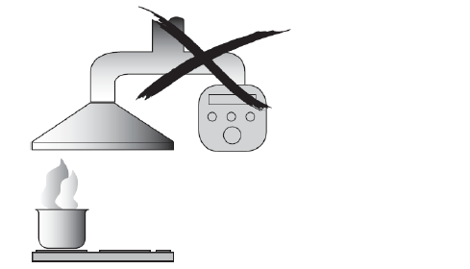
●The air must not be discharged into a flue that is used for exhausting fumes from appliances burning gas or other fuels.

Always to do:
●Important! Always switch off the electricity supply at the mains during installation and maintenance such as light bulb replacement.
●The range hood must be installed in accordance with the installation instructions and all measurements followed.
●All installation work must be carried out by a competent person or qualified electrician.
●Please dispose of the packing material carefully. Children are vulnerable to it.
● Pay attention to the sharp edges inside the range hood especially during installation and cleaning.
●Make sure the ducting has no bends sharper than 90 degrees as this will reduce the efficiency of the range hood.
●Warning: Failure to install the screws or fixing device in accordance with these instructions may result in electrical hazards
●Warning: Before obtaining access to terminals, all supply circuits must be disconnected.

Always to do:
●Always put lids on pots and pans when cooking on a gas range.
●When in extraction mode, air in the room is being removed by the range hood. Please make sure that proper ventilation measures are being observed. The range hood removes odours from room but not steam.
●Range hood is for domestic use only.


●If the supply cord is damaged, it must be replaced by the manufacturer, its service agent or similarly qualified persons in order to avoid a hazard.
●This range hood can be used by children aged from 8 years and above and persons with reduced physical, sensory or mental capabilities or lack of experience and knowledge if they have been given supervision or instruction concerning use of the range hood in a safe way and understand the hazards involved. Children shall not play with the range hood. Cleaning and user maintenance shall not be made by children without supervision.
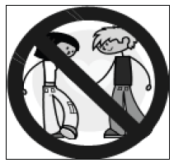

Always to do:
●Caution: The range hood and its accessible parts can become hot during operation. Be careful to avoid touching heating appliance elements. Children younger than 8 years old should stay away unless they are under permanent supervision.
●There shall be adequate ventilation of the room when the range hood is used at the same time as appliances burning gas or other fuels.
●There is a fire risk if cleaning is not carried out in accordance with the instructions
●Regulations concerning the discharge of air have to be fulfilled.
●Clean your range hood periodically by following the method given in the chapter MAINTENANCE.
●For safety reason, please use only the same size of fixing or mounting screw which are recommended in this instruction manual.
●Regarding the details about the method and frequency of cleaning, please refer to maintenance and cleaning section in the instruction manual.
●Cleaning and user maintenance shall not be made by children without supervision.
●When the range hood and appliances supplied with energy other than electricity are simultaneously in operation, the negative pressure in the room must not exceed 4 Pa (4 x 10-5 bar).
●WARNING: Danger of fire: do not store items on cooking surfaces.
●A steam cleaner is not to be used.
●NEVER try to extinguish a fire with water, but switch off the appliance and then cover flame e.g. with a lid or a fire blanket.

INSTALLATION
If you have an outlet to the outside, your range hood can be connected as below picture by means of an extraction duct (enamel, aluminum, flexible pipe or non-flammable material with an interior diameter of 150mm)

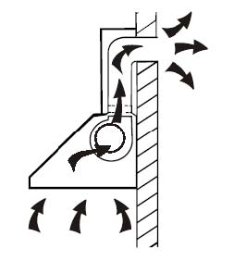

1. Before installation, turn the unit off and unplug it from the
outlet.

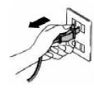

2. The range hood should be placed at a distance of 60~75cm above the cooking plane for best effect.
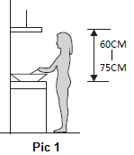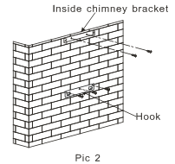
3. Install the hook on a suitable place once the installation height is fixed, and keep it in line. The fixed position of the inside chimney bracket is the place of chimney. See pic 2.
4. Install the expansion pipe and fix it with cable tie.Then put the range hood on the hook. See Pic 3.
5. Fix the outside chimney bracket on the outside chimney, and be sure that the inside chimney can be adjusted the height in it freely. Afterwards, install the chimney on the range hood and lead the expansion pipe to outside. See Pic 4.
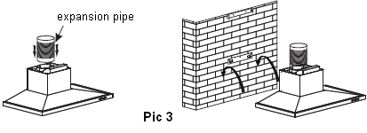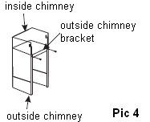
6. Adjust the height of the inside chimney to the position of the inside chimney bracket and fix on it by screw, after adjusting the position, fix the body with safety screw. See Pic 5.
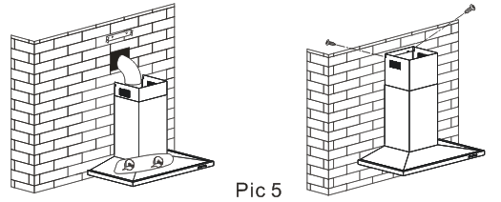

Note: The two safety vents are positioned on the back housing, with diameter of 6mm.

HINTS FOR EXHAUST DUCT INSTALLATION
The following rules must be strictly followed to obtain optimal air extraction:
• Keep expansion pipe short and straight.
• Do not reduce the size or restrict expansion pipe.
• When using expansion pipe always install the pipe pulled taut to minimize pressure loss.
• Failure to observe these basic instructions will reduce the performance and increase noise levels of the range hood.
• Any installation work must be carried out by a qualified electrician or competent person.
•Do not connect the ducting system of the hood to any existing ventilation system which is being used for any other appliance ,such as warmer tube, gas tube , hot wind tube.
•The angle of the bend of the expansion pipe should not be less than 120º; you must direct the pipe horizontally, or, alternatively, the pipe should go up from the initial point and should be led to an outer wall.
•After the installation ,make sure that the range hood is level to avoid grease collection at one end.
•Ensure the expansion pipe selected for installation complies with relevant standards and is fire retardant.
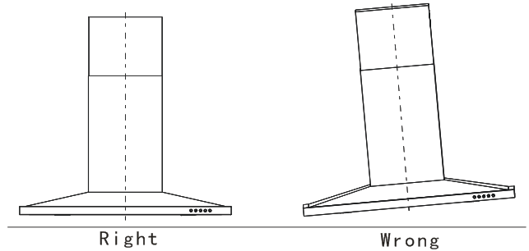

WARNING: | - For safety reason, please use only the same size of fixing or mounting screw which are recommended in this instruction manual.  - Failure to install the screws or fixing device in accordance with these instructions may result in electrical hazards.

Start Using Your Range Hood
Push button
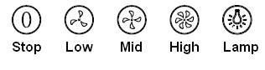
1) Push stop button, and the motor will stop.
2)Push the low button, and the motor runs at low speed.
3)Push the middle button, and the motor runs at mid speed.
4)Push the high button, and the motor runs at high speed.
5)Push the light button and the two lights will come on. Push it again and the light will turn off.

TROUBLESHOOTING
Fault | Possible Cause | Solution
Light on, but motor does not work | Fan switch turned off | Select a fan switch position.
Light on, but motor does not work | Fan switch failed | Contact service center.
Light on, but motor does not work | Motor failed | Contact service center.
Light does not work, motor does not work | House fuses blown | Reset/Replace fuses.
Light does not work, motor does not work | Power cord loose or disconnected | Refit cord to power outlet.  Switch power outlet on.
Oil leakage

Oil leakage | Leakage from the connection of chimney and cover | Take chimney down and seal.
Lights not working | Broken/Faulty globes | Replace globes as per this  instruction.
Insufficient suction | The distance between the range hood and the gas top is too far | Refit the range hood to the correct distance.
The Range hood inclines | The fixing screw not tight enough | Tighten the hanging screw and make it horizontal.


NOTE:
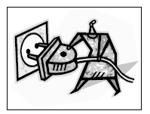
Any electrical repairs to this range hood must conform to your local, state laws. Please contact the service centre if in any doubt before undertaking any of the above. Always disconnect the unit from the power source when opening the unit.

MAINTENANCE AND CLEANING

Caution:

• Before maintenance or cleaning is carried out, the range hood should be disconnected from the main power supply. Ensure that the range hood is switched off at the wall socket and the plug removed.

• External surfaces are susceptible to scratches and abrasions, so please follow the cleaning instructions to ensure the best possible result is achieved without damage.

GENERAL
Cleaning and maintenance should be carried out with the range hood cold especially when cleaning. Avoid leaving alkaline or acid substances (lemon juice, vinegar etc.) on the surfaces.

STAINLESS STEEL
The stainless steel must be cleaned regularly (e.g. weekly) to ensure long life expectancy. Dry with a clean soft cloth. A specialized stainless-steel cleaning fluid may be used.
NOTE:
Ensure that wiping is done along with the grain of the stainless steel to prevent any unsightly crisscross scratching patterns from appearing.

CONTROL PANEL SURFACE
The inlay control panel can be cleaned using warm soapy water. Ensure the cloth is clean and well wrung before cleaning. Use a dry soft cloth to remove any excess moisture left after cleaning.

Important
Using neutral detergents and avoid using harsh cleaning chemicals, strong household detergents or products containing abrasives, as this will affect the range hood appearance and potentially remove any printing of artwork on the control panel and will void manufactures warrantee.
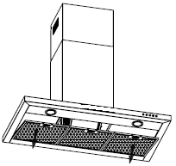
GREASE MESH FILTERS
The mesh filters can be cleaned by hand. Soak them for about 3 minute in water with a grease-loosening detergent then brush it gently with a soft brush. Please do not apply too much pressure, avoid to damage it . (Leave to dry naturally out of direct sun light)

Filters should be washed separately to crockery and kitchen utensils. it is advisable not to use rinse aid.
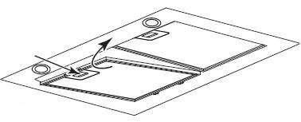
INSTALLING GREASE MESH FILTERS
• To install filters for the following four steps (See pic below):
- Angle the filter into slots at the back of the hood.
- Push the button on handle of the filter.
- Release the handle once the filter fits into a resting
position.
- Repeat to install all filters.

CARBON FILTER-not supplied
Activated carbon filter can be used to trap odors. Normally the activated carbon filter should be changed at three or six months according to your cooking habit. The installation procedure of activated carbon filter is as below.

- Before installing or replacing the carbon filters, please remove power to the unit.
- Press the filter lock and remove the mesh filter.
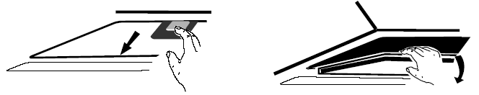
- Turn the carbon filter on both side of the motor anti-clockwise. Replace the carbon filters with the new carbon filters.
- Place the mesh filter.
- Connect the power supply to the wall socket.
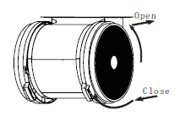
NOTE:
- Make sure the filter is securely locked. Otherwise, it would loosen and cause dangerous.
- When activated carbon filter attached, the suction power will be lowered.

BULB REPLACEMENT
Important :   | - The bulb must be replaced by the manufacturer, its service agent or similarly qualified persons.  - Always switch off the electricity supply before carrying out any operations on the appliance. When handling bulb, make sure it is completely cooldown before any direct contact to hands.  - When handling globes hold with a cloth or gloves to ensure perspiration does not come in contact with the globe as this can reduce the life of the globe.
Note:
- Before changing the lights, make sure that the appliance is plugged off.
- Protect against danger when changing lights, such as wearing gloves.

Changing the lights:
- Remove the grease filter.
- Find out the junction box, unscrew the screws on the junction box cover, then take down the junction box cover (If there is wire pressing plate which pressed the light wire, the wire pressing plate needs to be dismantled first).See pic 1.The junction box has version a and b, depending on different models.
- Find out the terminal of the light connecting wire and pull it out. See pic 2.
- Use a tool or the hand to press the spring splinter of both sides of LED light to the inside, until the light is pressed out, then slightly pull the light connecting wire out. See pic 3.
- Apply the reverse procedure to install the light back.
•ILCOS D code for this lamp is:DBR-2/65-H-64
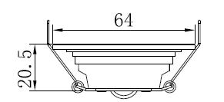
– LED modules –round lamp
– Max wattage: 2X2 W
– Voltage range: AC 220-240V
– Dimensions:

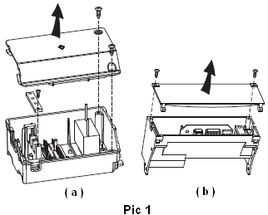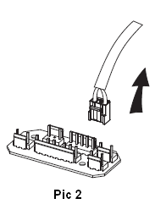

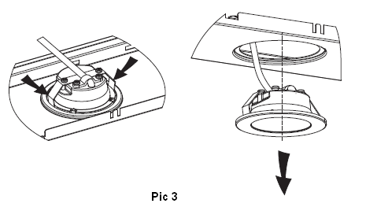

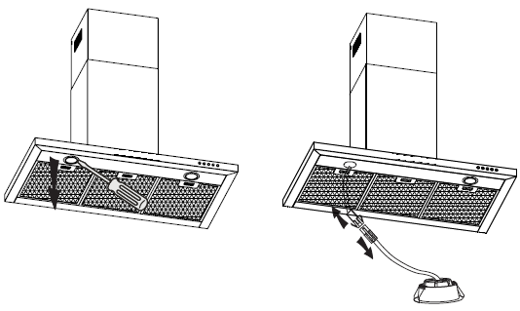

ENVIRONMENTAL PROTECTION:
 | This product is marked with the symbol on the selective sorting of waste electronic equipment. This means that this product must not be disposed of with household waste but must be supported by a system of selective collection in accordance with Directive 2012/19/EU. It will then be recycled or dismantled to minimize impacts on the environment, electrical and electronic products are potentially dangerous for the environment and human health due to the presence of hazardous substances. For more information, please contact your local or regional authorities.
NOTE:
The following shows how to reduce total environmental impact (e.g. energy use) of the cooking process).
- Install the range hood in a proper place where there is efficient ventilation.
- Clean the range hood regularly so as not to block the airway.
- Remember to switch off the range hood light after cooking.
- Remember to switch off the range hood after cooking.

INFORMATION FOR DISMANTLING
Do not dismantle the range hood in a way which is not shown in the user manual. The range hood could not be dismantled by user. At the end of life, the range hood should not be disposed of with household waste. Check with you Local Authority or retainer for recycling advice.

